**JNS urgent procedure ‘Great Belt Bridge accident 2nd Jan. 2019’**

**7May**2019

The Joint Network Secretariat (JNS) has issued the European Action Plan containing short-term risk mitigation measures on the use of pocket wagons. All the railway players across Europe are committed to maintaining rail as the safest land transport mode.

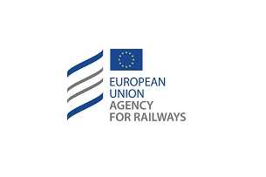

In the wake of the tragic railway accident that occurred on the Great Belt Bridge on January 2nd, all the railway players across Europe are committed to maintaining rail as the safest land transport mode.

The interim findings from the National Investigation Body (NIB) of Denmark show that semi-trailers may not be sufficiently secured against movement when transported on pocket wagons. In particular, the mechanism that ensures the locking of the kingpin in the hitch (type FW6170) of the pocket wagons was found to be unlocked on several occasions.

Subsequently, the NIB has issued a corresponding safety alert.

The National Safety Authority (NSA) of Denmark notified a request to launch a [Joint Network Secretariat (JNS)](https://www.era.europa.eu/activities/joint-network-secretariat_en) Urgent Procedure. The JNS Panel, representing the entire railway sector, agreed and established a task force which was organised and chaired by the European Union Agency for Railways.

The task force was composed of experts from the concerned sector organisations and has defined an [action plan](https://www.era.europa.eu/activities/joint-network-secretariat_en) containing short-term mitigation measures.

These measures aim at ensuring:

* appropriate maintenance of the hitch and in particular of the mechanism to lock the kingpin;
* correct positioning of semi-trailers on the pocket wagon for the entire duration of the trip; and
* the vertical locking of the semi-trailers’ kingpin.

The measures can be found at the [website of the European Union Agency for Railways](https://www.era.europa.eu/activities/joint-network-secretariat_en) and will be distributed to all actors involved in the transport of semi-trailers on pocket wagons.

For further information about this event, please [contact us](https://www.era.europa.eu/can-we-help-you/contact-us-0_en).